**1.03 Acquiring and referencing data**

**Learning intentions:**

Students will be able to:

* Describe the two different types of data and give examples
* Explain the difference between primary and secondary data sources
* Discuss data collection methods

**Success Criteria:**

**Vocabulary**

**Research and Data Analytics**

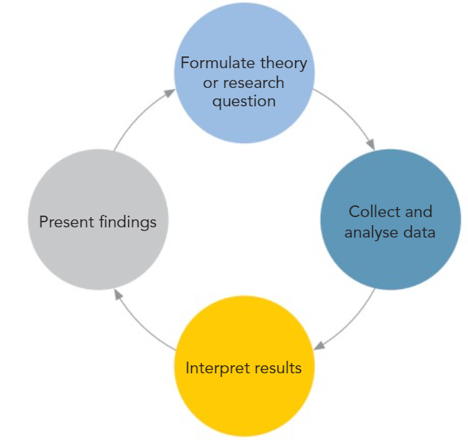

**Types of research data:**

* **Quantitative Data:**
  + Measurable and specific – statistics
  + Data is largely numerical
  + Data can be displayed as a chart or graph
  + Advantages:
    - Can have large sample, which provides statistical validity
    - Data can be interpreted and relationships identified
  + Disadvantages:
    - Surveys – may not provide in depth response
    - Time and budgetary restraints
* **Qualitative Data:**
  + About qualities or attributes – much harder to measure
  + Data from – interviews, focus groups, observation
  + This data will often need to be recorded and transcribed
  + Looking for patterns or themes
  + Advantages:
    - Rich study of participants
  + Disadvantages:
    - Small number of participants
    - May not provide a random sample - bias

**Primary and Secondary Data Sources:**

* **Primary Data source:**
  + Firsthand – eg: you conduct the survey
  + More up to date than secondary sources
* **Secondary Data sources:**
  + Secondary data is data collected by any party other than the researcher, including administrative data from programs, geodata from specialized sources, and **census** or other population data from governments.

**Data Collection Methods include:**

* Surveys
* Focus groups
* Open/closed questions
* Observation

Depending on the data collection type – what you need for referencing varies

To do:

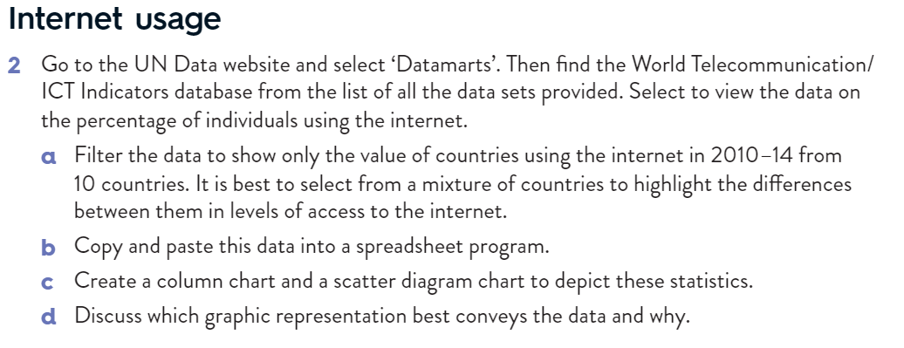

http://data.un.org/DataMartInfo.aspx

